Date | Class | Instructor’s Name

1
What Is ASD?
A brief overview of autism spectrum disorder (ASD)
Contents
What Is Autism Spectrum Disorder? 1
Causal Theories 2
How Is Autism Spectrum Disorder Diagnosed? 3
Family Supports and Resources 4
References 5

[Your Name]

What Is Autism Spectrum Disorder?

Autism spectrum disorder refers to a broad range of conditions characterized by difficulties with nonverbal and speech communication, repetitive behaviors, and social skills. Data from the Center for Disease Control estimates that in every 59 children, one is affected by autism in America. Other scholars define autism spectrum disorder as a complex developmental condition involving persistent difficulties in social interaction, restricted behaviors, nonverbal and speech communication. Autism is usually diagnosed in early childhood, with most signs presenting when the patient is two-three years old. However, in some cases, some children with ASD develop normally until toddlerhood, when they lose previously gained skills or stop acquiring skills (Goldstein & Ozonoff, 2018). Autism is also four times more common in boys than girls, and most girls with autism exhibit fewer common signs than boys. Autism spectrum disorder is a lifelong disorder; however, most children diagnosed with autism live independent, fulfilling, and productive lives. One of the major characteristics of children age eight years and below with ASD is avoiding eye contact. This characteristic is usually interpreted as a sign of personal and social indifference. However, studies indicate that eye contact causes a feeling of stress and discomfort. Such children also may not speak at all. About 30 percent of children with autism are minimally verbal; they speak less than 30 words. The majority of children with autism have difficulties speaking clearly or carrying out a conversation with another individual. Secondly, children with autism usually get very upset if they do not like a specific sound, smell, or taste. Most autistic children are sometimes under-sensitive or oversensitive to sensory information, implying that their senses take either too little or too much information from the environment around them. Lastly, autistic children at the age of 8 experience repetitive movements, for example, rocking, flicking of fingers, and flapping of hands (Sicile-Kira, 2014).

3

2
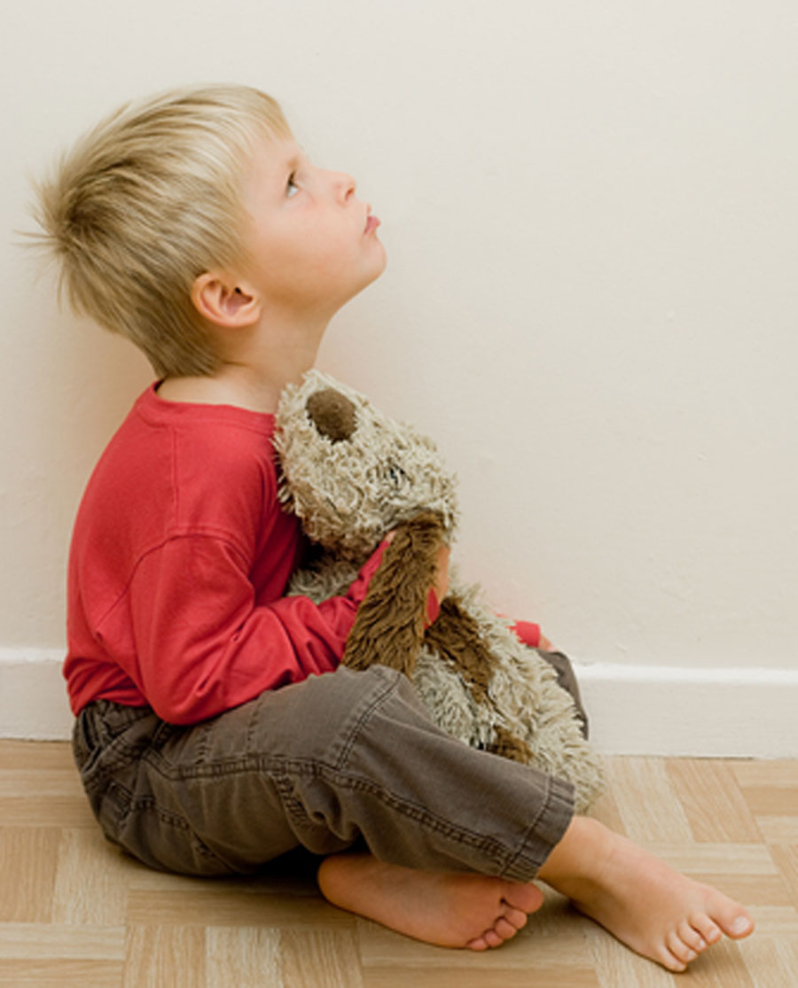 | Causal Theories
 | Autism was initially described as a result of hard parenting and also as a form of childhood schizophrenia. However, after a period, a new understanding related to developmental disorder developed. Finally, researchers defined autism as a spectrum of conditions ranging with different degrees of impairment. In 1943, Leo Kanner viewed autism as a profound emotional disturbance that hardly affects cognition. In 1952, he defined ASD as a psychiatric condition marked with detachment from reality. Between the 1950s and 1960s, autism was liked to unemotional and cold mothers known as "refrigerator mothers." However, by 1970 the “refrigerator mother” concept was disapproved, terming the disease as a pervasive development disorder different from schizophrenia. Previous versions of the manual left a huge gap in the clinical diagnostics process regarding interpretation and observations. However, DSM-III listed certain criteria for diagnosis. By 1987, the criteria were revised by adding a mild end of the spectrum: pervasive developmental disorder. In 2002 autism was presented as a spectrum of conditions in the DSM-IV. The features included childhood disintegrative disorder, Asperger’s disorder, and PDD.however since 1990 to 2003, researchers had tried to concentrate on autism genes. There was no link to autism. Therefore, they decided to characterize autism as an inclusive diagnosis vacillating from mild to severe. At this particular time, there was massive concern about the lack of consistency in how physicians in different clinics and states arrived at PDD-NOS or Asperger syndrome. To handle the concern, the DSM-5 introduced the term (autism spectrum disorder). The diagnosis consisted of persistent impairment in repetitive pattern behaviors, reciprocal social interaction, and social communication (Lehrer, 2018).
Autism is not a disability; it is a different ability.
The precise cause of autism spectrum disorder is unknown. the most recent research indicates the lack of exact cause. Some of the suspected risk factors of autism include exposure to environmental and heavy metals toxins, fatal exposure to the medications of thalidomide, valproic acid, and metabolic imbalances. It is crucial to follow the causal theory insight as it takes up a significant issue in the autism study between the world and the perceiver. It holds that transactions between the world and the perceiver should be analyzed according to the causal relation fundamental to the transaction. The theory is a progressive idea of personality development regarding the effect and cause. The theory assumes that behavior and personality result from experience starting from birth. The causal theory states that experience is the relevant and predominant determining factor. It holds that an individual’s behavior and personality indicate trauma and quality of nurturing. The theory is also important as it includes lessons from research on mirror neurons, cognitive-behavioral treatment, family system theory, and attachment theory (Atun-Einy & Ben-Sasson, 2018).

How Is Autism Spectrum Disorder Diagnosed?

examination for children with suspected autism spectrum disorder includes abnormal motor movements, such as hand flapping and awkward walk. The examination may also reveal dermatologic anomalies, abnormal head circumstances, and physical abuse inflicted by teachers or parents. Other findings include self-injury behaviors such as head punching, self-biting, picking at the skin, and sexual abuse. The definition of ASD in DSM-5 includes initial autistic disorder, pervasive developmental disorder, disintegrative child disorder, and Asperger’s order. Autism spectrum disorder is characterized by restricted, repetitive behaviors, activities, and interests. It is also characterized by deficits in social interaction and social communication. The symptoms, as mentioned earlier, are present from childhood and impair and limit daily functioning. Both components are necessary for a diagnosis of autism spectrum disorder. The diagnostic criteria involve testing and neuroimaging studies. There are no blood studies recommend for the routine assessment of autism spectrum disorder. A metabolic workup should be considered personal even though different metabolic abnormalities have been identified in the investigation of children with ASD, such as impaired amines metabolism and reduced serum biotinidase. Studies can be helpful in the evaluation of autism spectrum disorder in different areas. The psychophysiological assessment may indicate a lack of response habituation to constantly present stimuli. In this assessment, auditory over selectivity may be seen. Polysomnography demonstrates seizure discharges and identifies sleep disorders.EEG studies exclude biotin-responsive infantile encephalopathy and seizure disorder. In terms of neuroimaging studies, there is no clinical evidence to back up the role of routine clinical neuroimaging in the diagnostic evaluation of autism spectrum disorder. Even though characteristic abnormalities have been pinpointed, there is still a lack of a diagnosis. Psychophyslogic assessment is crucial in the assessment of children with ASD. Besides, children with autism spectrum disorder are less likely to show the response habituation in electrodermal activity, vasoconstrictive peripheral pulse amplitude, and respiratory period to repeatedly presented stimuli. Children with ASD may also fail to demonstrate auditory over selectively. Polysomnography facilitates the diagnosis of treatable comorbid disorders. Genetic testing is used in children with intellectual disabilities and families with a history of fragile X. SPECT scanning, PET scanning, CT scanning, and MRI usually yield inconsistent results in evaluating autism spectrum disorder (Ohashi et al., 2015).

3

4
Family Supports and Resources

Center for Parenting Information and Resources
there are different national resources for families' use, such as the Center for Parenting Information and Resources.CPIR acts as a central resource for product and information to the community of Parent Training Information and the Community Parent Resource Centers (CPRCs). The PTI is found in every state and has adequate training and information tailored for parents. The CPRCs throughout the nation serve the underserved and targeted communities.
Center on Technology and Disability
the Center on Technology and Disability is another center designed to increase the capacity of providers and families to advocate for, implement and acquire instructional and assistive technology practices, services, and devices. Such technologies have a great impact on youth, children, and toddlers with ASD.
National Professional Development Center on Autism Spectrum Disorders

the national professional development center on autism spectrum disorders works to develop resources for technical assistance providers, therapists, and teachers who work with persons with ASD.
The U.S Department of Education

When children with ASD enter public schools, they have the rights under state and federal laws. The department's special education programs office supports projects that offer technical assistance and information to families of children with ASD.

References
Atun-Einy, O., & Ben-Sasson, A. (2018). Pediatric allied healthcare professionals’ knowledge and self-efficacy regarding ASD. Research in Autism Spectrum Disorders, 47, 1-13. https://doi.org/10.1016/j.rasd.2017.12.001
Goldstein, S., & Ozonoff, S. (2018). Assessment of autism spectrum disorder (2nd ed.). Guilford Publications.
Lehrer, K. (2018). Theory of knowledge (2nd ed.). Routledge.
Ohashi, K., Mizuno, Y., Miyachi, T., Asai, T., Imaeda, M., & Saitoh, S. (2015). Concordance of DSM-5 and DSM-IV-TR classifications for autism spectrum disorder. Pediatrics International, 57(6), 1097-1100. https://doi.org/10.1111/ped.12704
Sicile-Kira, C. (2014). Autism spectrum disorder: The complete guide to understanding autism. TarcherPerigee.

5

